SCENARIO 2

1.Buy 2 Fundamental and 3 Advanced courses



Write the following queries

2.Which will select non admin user all courses.

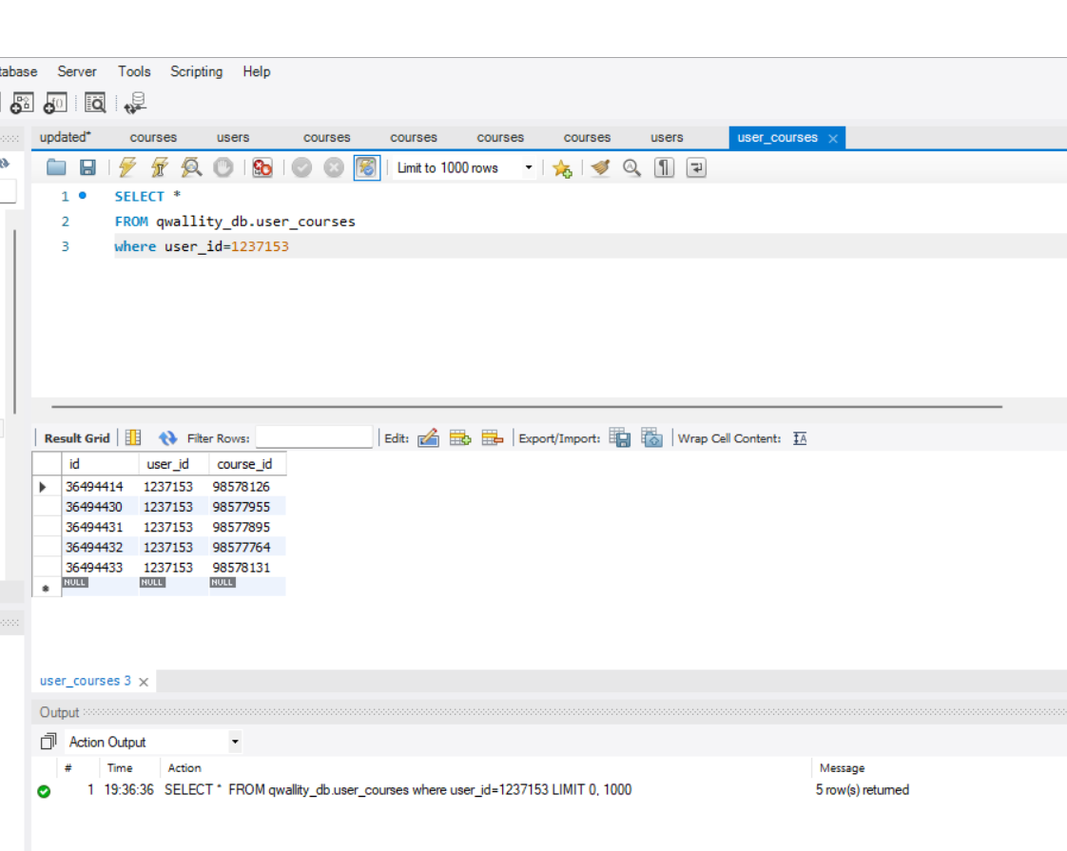

3.Which will select count of Fundamental and Advanced course

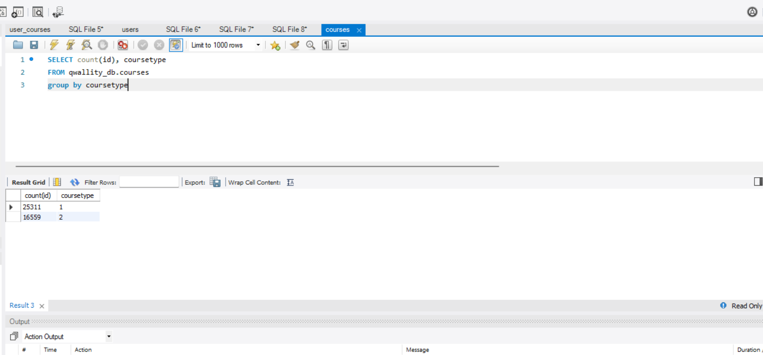

4.Which will insert new Fundamental course to non admin account

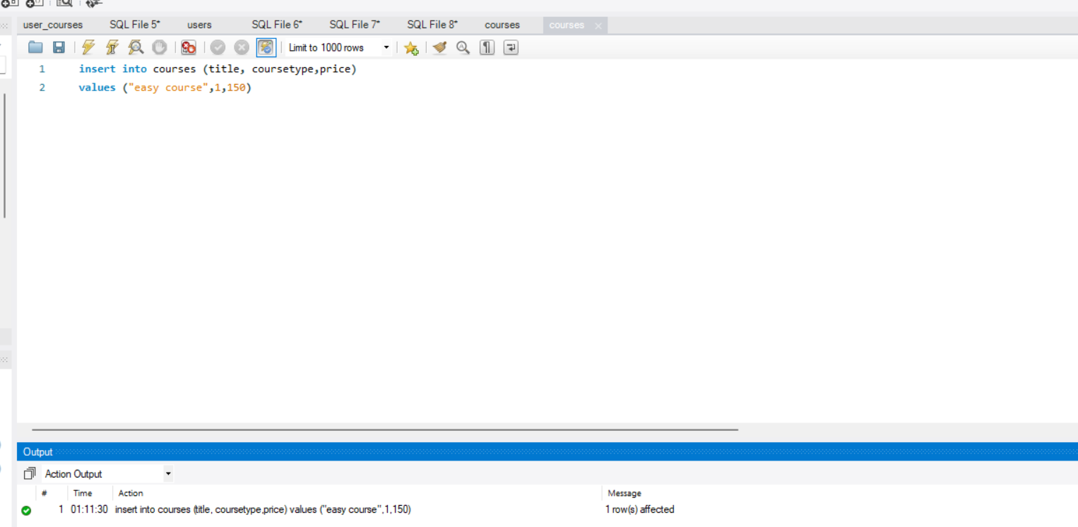

5.Which will update one of the Advanced course price to “20”

SCENARIO 3

Write the following queries

1.Which will give count of the all non admin and admin users

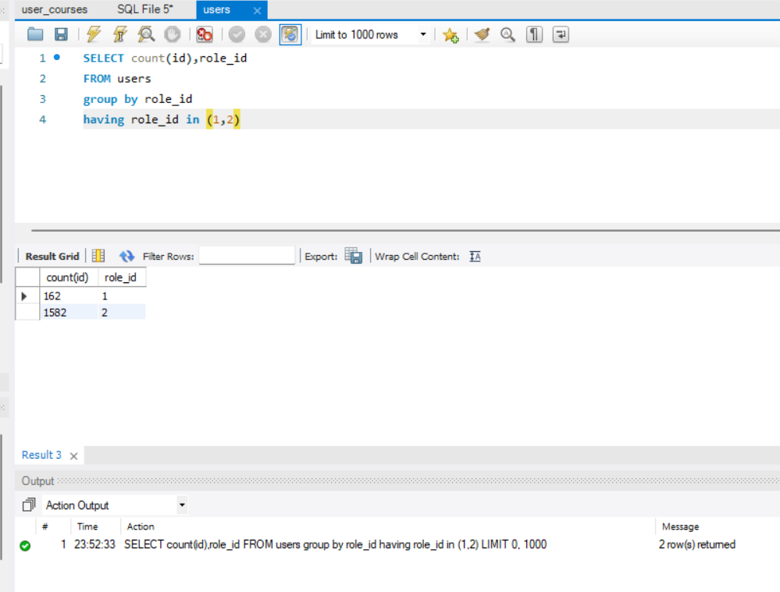

2 Which will select all users who account is more than 100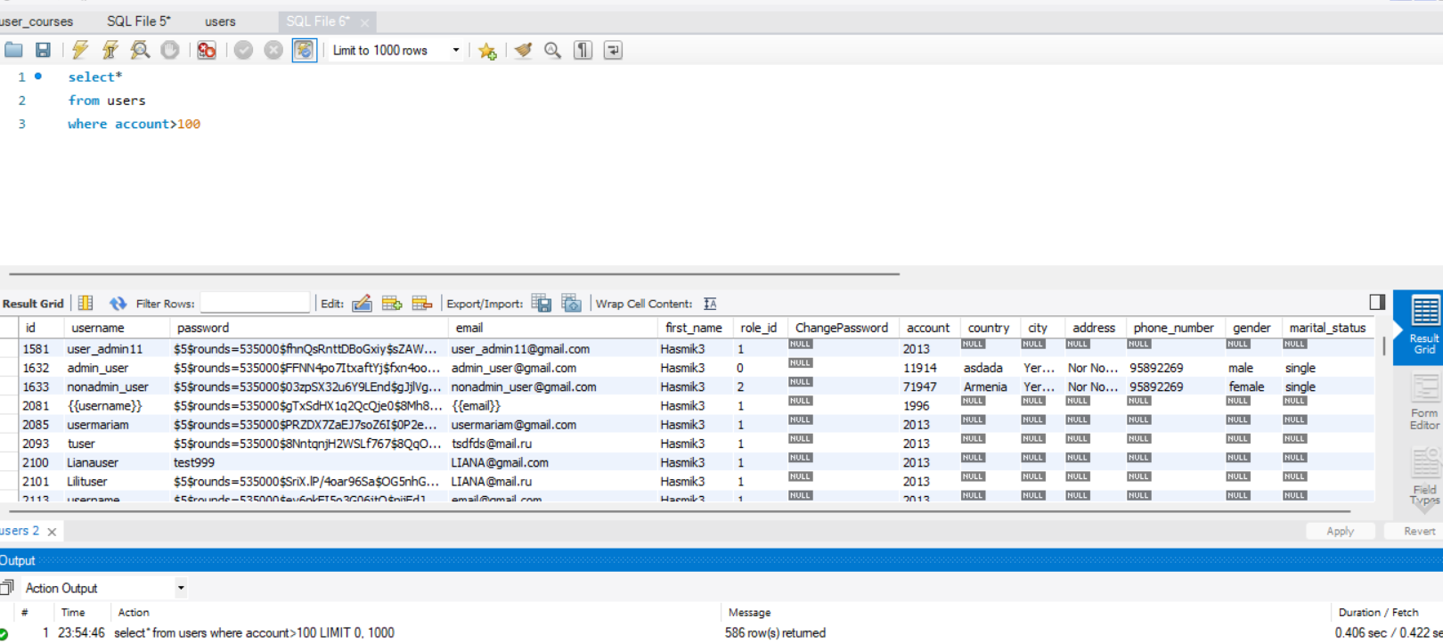

3.Which will group by username

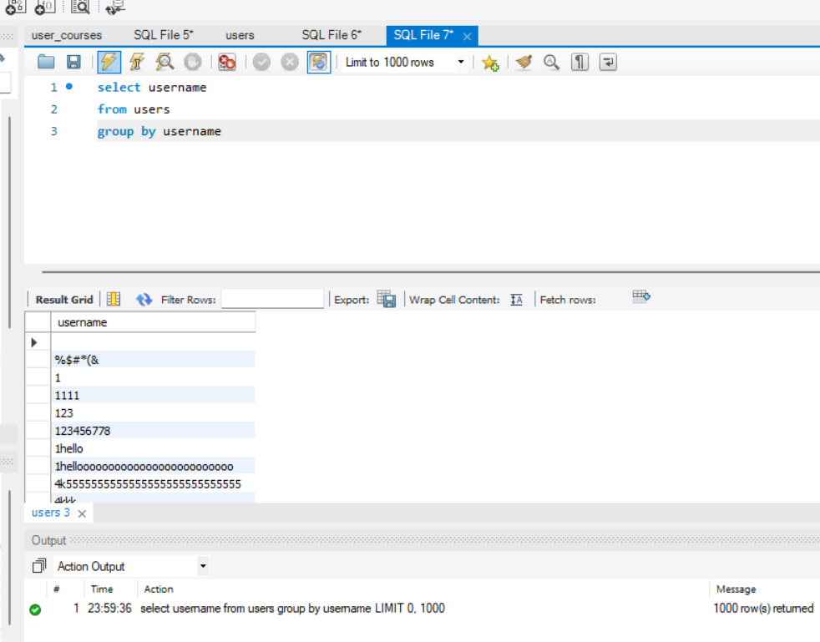

4Which will give all users who name start with “Ann”

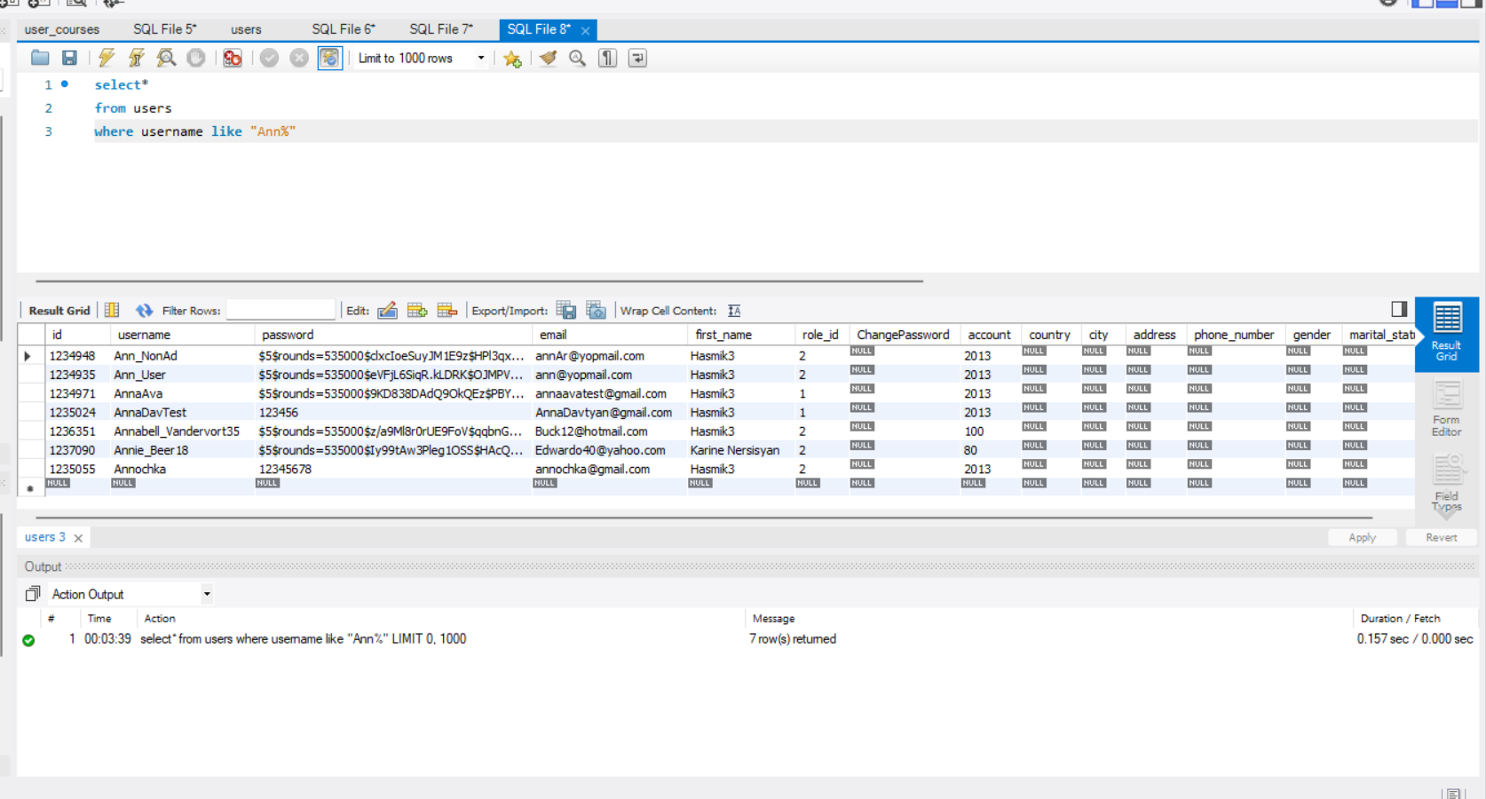

5 Which will give all users who name 2nd letter is “n”

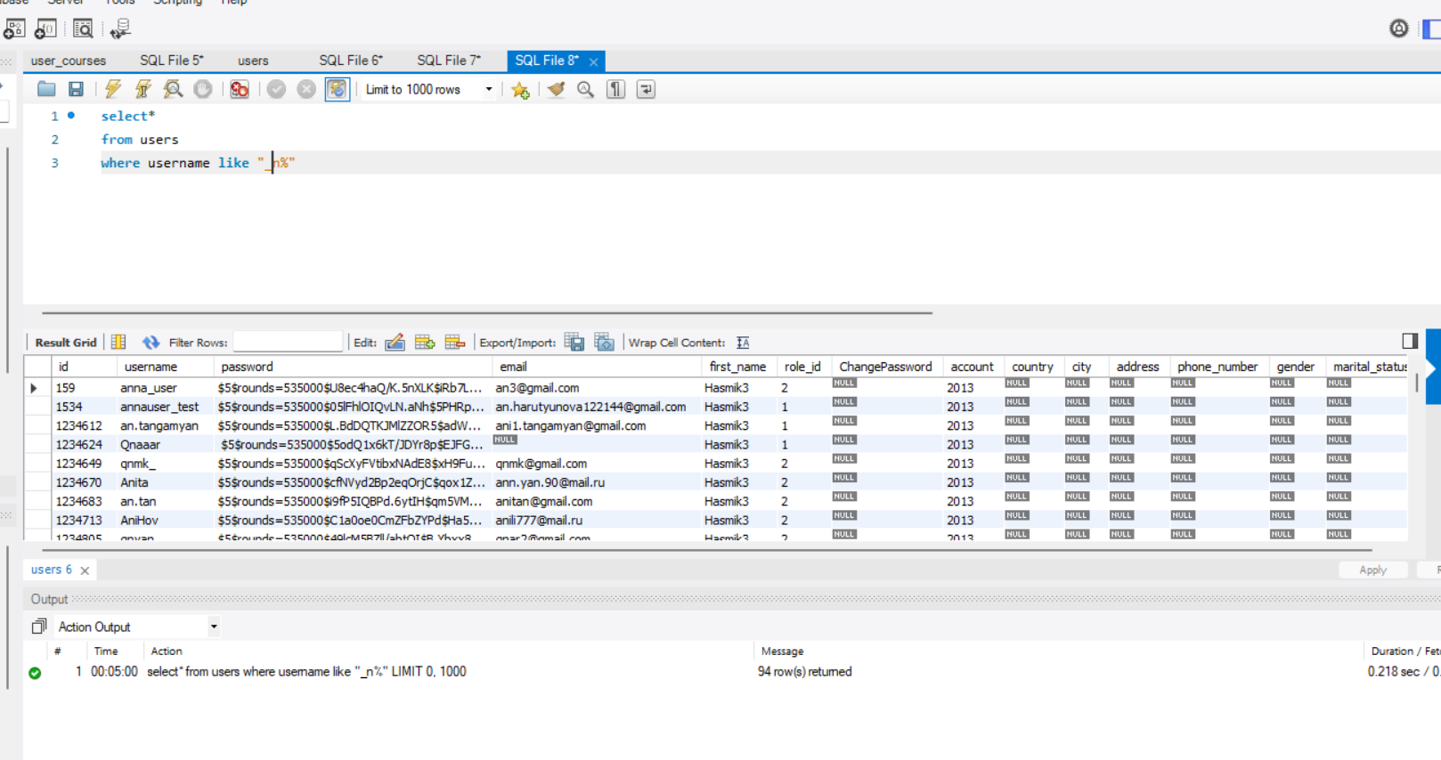

6 Which will insert new user with all fields